EX NO: 27
CALCULATION OF PROCESSING GAIN AND GENERATION OF PN SEQUENCES FOR SPREAD SPECTRUM COMMUNICATION USING MATLAB SIMULATION
Objectives:
1. To generate a pseudo-noise (PN) sequence using MATLAB for spread spectrum communication.
2. To determine the processing gain from the spreading factor or chip-to-bit ratio.
3. To perform spreading of a binary data sequence using the generated PN sequence.
4. To observe and analyze the characteristics of the generated PN sequence and spread signal.
5. To verify the relationship between processing gain, spreading factor, and bandwidth expansion.
6. To develop MATLAB-based skills for analyzing basic spread spectrum parameters.
Procedure :
1. Open the MATLAB software and create a new script file.
2. Clear the command window, workspace, and close all previously opened figure windows.
3. Define the required communication system parameters.
4. Calculate the processing gain of the spread spectrum system.
5. Generate a Pseudo Noise (PN) sequence.
6. Display the generated PN sequence in the MATLAB command window.
7. Plot the PN sequence using an appropriate plotting function.
8. Label the axes and provide an appropriate title for the plot.
9. Execute the MATLAB program.
10. Observe the calculated processing gain and the generated PN sequence.
11. Analyze the distribution of the PN sequence.
12. Verify that the generated sequence exhibits pseudo-random characteristics suitable for spread spectrum communication.

Program:
clc;
clear;
close all;
% Processing Gain
Rb = 1000; % Data Rate (bps)
Rc = 10000; % Chip Rate (chips/s)
PG = Rc/Rb;
PG_dB = 10*log10(PG);
fprintf('Processing Gain = %.2f\n', PG);
fprintf('Processing Gain (dB) = %.2f dB\n', PG_dB);
% Generate PN Sequence
% 31-bit PN sequence pn = randi([0 1],1,31);
% Display
disp('PN Sequence:');
disp(pn);
% Plot
figure;
stem(pn,'filled');
title('Pseudo Noise (PN) Sequence');
xlabel('Chip Number');
ylabel('Chip Value');
grid on;
Output:
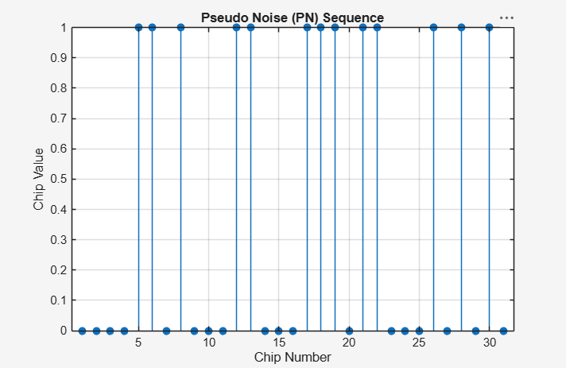
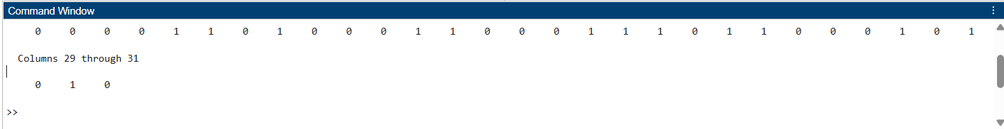
Result:
- The processing gain of the spread spectrum communication system was successfully calculated, and the corresponding PN sequence was generated using MATLAB.
- ii) The generated PN sequence exhibited pseudo-random characteristics, demonstrating its suitability for signal spreading and interference reduction in spread spectrum communication systems.

